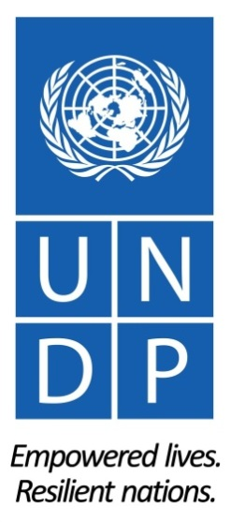

UNDP Global Knowledge Management
Project Progress Report 2015 to the Project Board
Development Impact Group, BPPS

I. Executive Summary

The project “UNDP Knowledge Management 2014-2017 under the Global Programme V” is the primary vessel to implement UNDP’s Knowledge Management Strategy Framework 2014-2017. This progress report, prepared by BPPS/DIG for the Project Board of the above project, provides status updates on the global KM 2014-2017 project activities and outputs for the period of January to December 2015.

UNDP’s global KM project prioritizes the following five outputs to strengthen UNDP’s role as knowledge broker, builder of capacities and facilitator of exchanges in KM for development practice, each with distinct activities:

- Knowledge capture and lessons learning
- Knowledge exchange and networking
- Openness and knowledge sharing
- Measurement and reporting
- KM and learning in HR and procurement

The beneficiaries of this project are UNDP staff, consultants and project staff at global, regional and country level, as well as clients, partners and the general public that may benefit from UNDP’s knowledge, advisory and support services.

Key achievements during the project period 2015 include the preparation of the relaunch of UNDP’s re-aligned knowledge networks and a range of successful public knowledge consultations for and with partners. UNDP also made strides in advancing its internal KM systems, namely the public library of knowledge products, the pipeline of knowledge products in development and a database of lessons learned.

Unforeseen by the original project work plan, the KM project also took charge of transitioning UNDP’s internal peer-to-peer networking environment Teamworks to Yammer under Microsoft’s suite of Office 365 collaboration tools, an initiative that had been put forward by BMS/OIMT and that DIG joined.

As opposed to 2014, when the primary source of funding for the project was a Global Programme allocation of $345,000, the main source of funds in 2015 was an XB allocation of $220,000, complemented by additional cost-sharing contributions from client service engagements.

Overall project delivery in 2015 was $233,208.40, or 106% of the allocated XB funds of $220,000.

The content of this progress report is expected to inform a number of key strategic decisions to be taken by the KM Project Board regarding implementation of key deliverables in 2015:

- Support for the concept of lessons learned capture in the Corporate Planning System when tabled in PCG;
- How to mitigate the high risk of retiring UNDP’s important public consultation platform by 31 December 2016.

II. Implementation Status of KM Activities

2015 Knowledge Management Survey
In support of the implementation of its KM activities, the DIG KM team conducted and analyzed a global survey on Knowledge Management focusing on (a) how best to re-organize UNDP's knowledge networks, (b) how to improve systematization of lessons learned, and (c) how UNDP staff are using the UN Teamworks platform so far. The survey was distributed in March 2015 to the 3172 members of the former UNDP Practice Networks (CPRP-net, PR-net, EE-net, DGP-net, HIV-net, Gender-Net and Capacity-Net) with UNDP email addresses, and received a total of 550 responses. The full survey report can be accessed here and its results fed directly into the project’s work on knowledge networks, lessons learned and IT infrastructure for KM.

Output 1: Improved mechanisms and systems for knowledge capture and lessons learning in place

Activity 1 - Lessons Learned Database

Through this activity, the project aims to produce a lessons learned database with the overall purpose to retain substantive lessons for staff to tap into when designing, monitoring, and implementing projects. According to the global KM project document, these lessons should be “systematically entered during the project implementation and closure, based on inputs from evaluations, project reports or other reflection and learning.”

After inconclusive discussion with the Project Board of the concept note that was prepared in 2014, and the mixed feedback received on the development of an initial Excel-based prototype in early 2015, the Project Executive decided to pursue an approach that would not establish a new mechanism next to existing UNDP systems, but integrate a facility for lessons learned capture within the existing Corporate Planning System. A revised concept note to this extent was shared with the Executive Office.

Based on this concept note, DIG established in close cooperation with ExO by the end of 2015 a facility to capture lessons learned from evaluation that are relevant to COs as part of the new 2015 ROAR template within the Corporate Planning System. This database table is expected to serve as the technical foundation for capturing lessons from other processes going forward, such as the Project Management QA in 2016. DIG was able to establish this without any cost to the project for IT development so far, but anticipates some IT cost for 2016 to connect it with the Project Management QA module in the Corporate Planning System.

In addition to developing the technical foundation for a lessons learned database, DIG also invested in more in-depth analysis of lessons learned from ROAR submissions and decentralized evaluations in 2014 and 2015. The project team hired a consultant to produce a report “Lessons Learned from the Results Oriented Annual Reports (ROAR) and Evaluations” for the years 2014 and 2015, which will be delivered by March 2016. While originally the cost of the consultancy was supposed to be shared between the DIG KM project and the DIG results team budget, the KM team eventually covered the full cost of the report.

Table1: Project Budget – Activity 1
Activity | Approved Budget (minus ISS) | Expenditure | Purpose
Lessons Learned Database | $19,250 | $48,600 | Production of report “Lessons Learned from the Results Oriented Annual Reports and Evaluations” for the years 2014 and 2015

Owner: Johannes Schunter (Lessons Learned Database) and Bernardo Cocco (Lesson Learned Analysis Reports).

Next Steps: Initiate IT development to embed Lessons Learned capture mechanism within the Project Management QA module in the Corporate Planning System.

Activity 2 - Lessons Learned Capture:

An effective lessons learned database will need to rely on ways to capture lessons learned, so that these can be adapted and adopted as critical input to better programming. Thus, this activity aims to supply mechanisms for populating the lessons learned database.

In 2015 continued the ongoing prototype for proactively extracting lessons learned at the regional level through the UNV volunteer stationed as Regional Lessons Learned Officer in Addis Ababa, end extended the assignment for 3 month until the end of 2015. In addition to the planned expenditure of $39,113.03 for the UNV volunteer assignment 2015, the project also used $4,489.25 for travel of the UNV volunteer to various country offices in the Africa region, where she met with project managers and portfolio managers and conducted dedicated lessons learned extraction on request.

By the end of her assignment, the UNV volunteer had engaged with nine Country Offices in the Africa region on dedicated Lessons Learned capture exercises, and delivered the following lessons learned products:
- GEF PIMS 3603 00077723 Project Lessons Learned Report: https://undp.unteamworks.org/node/521427
- LESSONS LEARNED REPORT: GEF-FINANCED, UNDP-SUPPORTED PROJECT ON CAPACITY BUILDING AND KNOWLEDGE MANAGEMENT FOR SUSTAINABLE LAND MANAGEMENT IN LESOTHO: https://undp.unteamworks.org/node/521332
- Ethiopia re-igniting knowledge management sharing and learning processes: https://undp.unteamworks.org/node/468689
- Conflict Analysis for Development challenging a standard development approach: https://undp.unteamworks.org/node/472772
- How can one practically prioritize knowledge management activities? https://undp.unteamworks.org/node/513506
- Local authorities leading community lead development in Lesotho: https://undp.unteamworks.org/node/508974
- The Global Environment Facility supporting the preservation of the unique gene pool of Lesotho’s Indigenous chickens:
https://undp.unteamworks.org/node/521330
- Malawi supports innovation for sustainable and inclusive growth: https://undp.unteamworks.org/node/521420
- Desk Research Media Reform in Africa:
https://undp.unteamworks.org/node/521425
- UNDP and Youth Entrepreneurship in Africa:
https://undp.unteamworks.org/node/504758
- Webinar - From techies to technopreneurs: a collaborative business incubation project: https://undp.unteamworks.org/node/500632
- Webinar - UNDP's support to Decentralization Processes in Africa: https://undp.unteamworks.org/node/514054
- Rwanda Writeshop:
https://undp.unteamworks.org/node/517502
- Back to Office Report Rwanda:
https://undp.unteamworks.org/node/521389
- Back to Office Report Lesotho
https://undp.unteamworks.org/node/508979

The project team also conducted an After Action Review at the end of the assignment to reflect on the value of the prototype, which drew the following conclusions:

- The concept of the prototype feeds directly into the imperative to invest in systematic approaches for identifying and collecting lessons learned. So the overall idea of deploying a UNV volunteer as Regional Lessons Learned Officer is still considered promising.
- If the prototype were go into a new iteration, the project would need to involve the Regional Bureau more, so the Bureau would co-own the lessons learned mandate. This could potentially be achieved by asking the Bureau to co-fund the UNV volunteer position.
- The project would need to find ways to have the CO commit more to the exercise. We could try triggering more corporate messaging on the importance of collecting lessons learned at the country level. This could potentially also be linked to the call for the ROAR, which also includes a lessons learned question.
- The project should either ask RBA to co-fund additional time for the UNV volunteer, or consider launching an improved version of this prototype in another region based on the lessons learned from this one.

Table 2: Project Budget – Activity 2
Activity | Approved Budget | Expenditure | Purpose
Lessons Learned Capture | $47,777.33 | $43,602.28 | - UNV Volunteer deployment in Addis and UNV Volunteer travel

Owner: Johannes Schunter

Activity 4 - Revision of K-products Development and Dissemination Process:

In 2015, this initiative focused on the mainstreaming of a global pipeline of products in development and the revision of the existing public global library, including the typology for knowledge products.

BPPS pipeline for knowledge products in development
After the launch of the BPPS pipeline for knowledge products in development end of 2014, UNDP successfully managed the pipeline process by coordinating with focal points from each profession, and among others leveraged the pipeline at the end of 2015 to swiftly report on the BPPS ROAR question on products produced in 2015. In addition, the team initiated further technical improvements to the pipeline website to improve coherence and monitoring.
Global library of knowledge products and publications
The global KM project identified the need for a central repository in which all of the organization’s official knowledge products and publications can be stored, searched and accessed. The 2015 KM survey showed that there is indeed strong demand among staff for such a global library. In 2015, DIG worked closely with BERA to build on the existing library page on the UNDP website and improve it to provide access to public users to all of UNDP’s public products bearing a UNDP logo and allow for interaction with public users through a ratings feature and social media sharing capabilities. In turn, the system will track views, downloads and interactions with external users to provide data for adequate tracking and performance measurement of the reach, quality and potential impact of products and publications.
The KM team developed in cooperation BERA specifications for such a global library of knowledge products and led the process of developing a taxonomy and identifying content from various global and regional websites to identify the list of publications to be made available in the library.

Table 3: Project Budget – Activity 4
Activity | Approved Budget | Expenditure | Purpose
Revision of Knowledge products development and dissemination process | $25,000 | $21,300 | - IT development for technical improvements to Pipeline of k-Products  - Consultancy for re-tagging of existing library content based on new taxonomy

Next Steps: Monitor development and roll-out of agreed features with BERA web team.

Output 2: Improved mechanisms and systems for knowledge exchange and networking in place

Activity 6 - Re-alignment of UNDP’s Knowledge Networks
New Knowledge Networks
In accordance with UNDP’s Strategic Plan 2014-2017, DIG has been working with teams across the organization (including BPPS, BERA and BMS) to realign its legacy Practice Networks with the aim of facilitating more interdisciplinary knowledge exchange while preserving their successful elements. In 2015, the KM team engaged in consultations across the house to re-start the long-dormant knowledge networks, consulting with colleagues in Country Offices, Regional Centers, BPPS Professions, a number of Resident Representatives, as well as colleagues in the Executive Office. At the ExO’s prompt, the team also presented the proposal to the Programme Coordination Committee (PCG), a particularly important step to build consensus. All these consultations offered constructive feedback on how to improve the structure and offerings of the networks prior to their launch. The main takeaways from these consultations fall within the following areas:
- Need for network alignment to strategic priorities and channels for non-substantive topics;
- Push to move away from thematic silos and encourage discussions on cross-cutting corporate priorities;
- Need for more external interaction to promote UNDP’s expertise as well as to pull in the best knowledge from outside to feed into our work;
- Focus on knowledge capture and codification, how this supports the organization, and how it can be packaged to make it easy and engaging for colleagues to interact with.
The final proposal (a) emphasizes supporting external facing discussions, consultations, and exchanges and (b) opts for a more flexible network structure which adapts to the needs of the organization, both in strategic and practical terms. The project team believes this will result in a manageable compromise between the need to drive targeted discussions and the need to supply channels for practitioners to exchange knowledge.
For the public facing side, the project supported the introduction of a single corporate Policy Dialogues Space where colleagues interact with external experts, partners, donors, stakeholders, other UN colleagues and development actors in UNDP-led global discussions on relevant and timely issues. The discussions hosted here are cross-cutting in nature, aligned with the Sustainable Development Goals and UNDP’s Strategic Plan Areas of Work: “Inclusive Governance”, “Sustainable Development Pathways” and “Resilience”. The launch of specific discussions is demand driven, catering to both business units which have a need to consult and discuss pertinent issues with an external audience as well as to senior management who wish to drive strategic discussions. In November 2015, the project supported a public consultation on UNDP’s HIV, Health and Development Strategy which focused on the social, structural and economic determinants of HIV and health. The numerous contributions received from targeted partners, UN agencies, academia and other stakeholders have informed the overall strategy which will shape UNDP’s work in HIV and health over the next six years. This service line is now open for all UNDP units to take advantage of.

The new Knowledge Networks are structured around (a) Communications, (b) Governance and Peacebuilding, (c) Gender, (d) HIV and Health, (e) Sustainable Development, (f) Management Services, (g) Programme Effectiveness, and (h) Crisis Response and Resilience. The structure will remain flexible, adapting to fit the needs of the organization. The KM team has been working with the eventual facilitators of these Knowledge Networks since July 2015 on designing the objectives, scope and service portfolios of their respective Networks. With the aim of preserving continuity and institutional memory from the legacy Practice networks, there will be an automatic rollover of network membership to the new corresponding Knowledge Networks.

The launch of these Networks will happen through message to all staff explaining the rationale for realignment, opportunities for active involvement and vision moving forward. The Governance and Peacebuilding Network will launch mid-February with an e-Discussion on Preventing Violent Extremism, to gather input and experience from colleagues globally to influence UNDP’s strategy on PVE.

The Networks will reside on UNDP’s Microsoft Office 365 environment, integrating our corporate online tools such as webmail, intranet, calendar, OneDrive document storage, Yammer social networking, while also preserving an email channel for the most pertinent updates. In addition, the Networks site will also offer a snapshot of ongoing and upcoming global knowledge events as well as tailored guidance and information on our corporate knowledge tools.

Next Steps: Launch networks in mid-February 2016

Owner: Janine Civitate

UNDP’s Peer Networking Infrastructure: Transition from Teamworks to Yammer

UNDP needs an easy-to-use, integrated tool to support peer networking, information sharing and knowledge exchanges within the organization. Since 2010, the Drupal-based, in-house developed Teamworks platform has served this function as the first-of-its-kind corporate social networking platform within the UN system. The investment in this approach paid off for UNDP with 84% of staff in 2012 finding the Teamworks beneficial for UNDP’s business and 70% declaring it beneficial for their own work. It also provided UNDP with a platform to support governments and partners with a string of successful public dialogues initiatives, such as the Rio+20 Dialogues, or the World We Want 2015.

In 2015, Teamworks found itself within a marketplace of commercial corporate social networking solutions which were not available at the time of Teamworks’ inception, but which share its vision of leveraging the benefits of peer-to-peer networking for an entire organization. Significant investments would be required in order for Teamworks to stay competitive in terms of functionality, usability and performance. At the same time, UNDP owns as part of Microsoft’s Office365 solution the social networking component ‘Yammer’ which replicates many of Teamworks’ features. On 28 May 2015, the ICT Governance Board approved a business case presented jointly by OIMT, DIG and RBA to move UNDP’s internal peer networking function to Yammer, while retaining UNDP’s external dialogue function (which cannot be served by Yammer) on a cloud-based version of Teamworks. Following the recommendations by the ICT Governance Board, the proposal was then submitted to the OPG who approved it in October 2015 through an e-review. The proposal was then signed by the Associate Administrator in November 2015.
Through such a transition UNDP will continue to champion the vision of the Teamworks platform as corporate peer networking environment for staff by transitioning to a more state-of-the-art, off-the-shelf commercial architecture.
This transition is being accompanied by a change management plan developed jointly by OIMT and DIG. The Project Board first met on 20 November and approved the Project Initiation Document. Other elements completed and approved in December include Yammer Usage Guidelines, and Yammer Administration SOP.
While this initiative has originally not been part of the KM project, it fits naturally under the overall Output 2: “Improved mechanisms and systems for knowledge exchange and networking in place”. The KM project team has been working on a change management plan for the transition, particularly focusing on the phasing out of internal Teamworks domain, content and group transition from Teamworks to UNDP’s Microsoft enterprise solution, along with training and end-user support. Official communication is scheduled for Q1 2016 to coincide with agreement from the Change Control Board on this plan. The KM project team therefore suggests that the Project Board approve an official amendment to add the Teamworks-Yammer transition, as well as ongoing Yammer change management as a new distinct project activity under the project’s Output 2.

Next Steps: Finalize project and change management plan and initiate transition in Q1 2016. Amend project work plan to add activity for Teamworks-Yammer transition under Output 2.

Owner: Gayan Peiris

Table 4: Project Budget – Activity 11
Activity | Approved Budget | Expenditure | Purpose
Knowledge Networking | $18,170.22 | $18,170.22 | - Consultancy to support change management transition from Teamworks to Yammer  - iContact mailing tool subscription

Output 3: UNDP’s openness and knowledge sharing about its work increased

Activity 9 - Public Online Dialogues and Consultations

An extension of Teamworks platform with highly customized interfaces has successfully serviced large-scale external-facing business of public consultations such as the Rio+20 Online Dialogues, World We Want 2015, and World Humanitarian Summit Consultations. In 2015, UNDP has been supporting the following ongoing public dialogues and consultation projects with the consultations platform, as well as technical project management and facilitation advisory support:
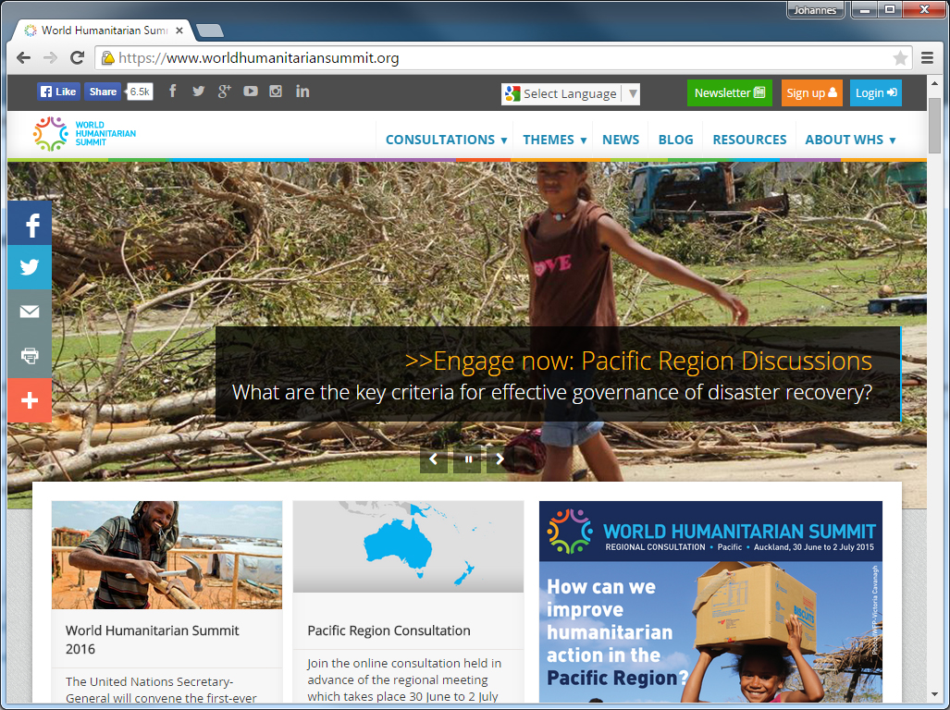
- World Humanitarian Summit Consultations (in collaboration with UNOCHA)
The WHS consultations platform has hosted 15 successful global and regional e-discussions to date, to prepare for the World Humanitarian Summit in May 2016. It is used as an advocacy tool generating nearly one million page views from 124,000 users in 225 countries.

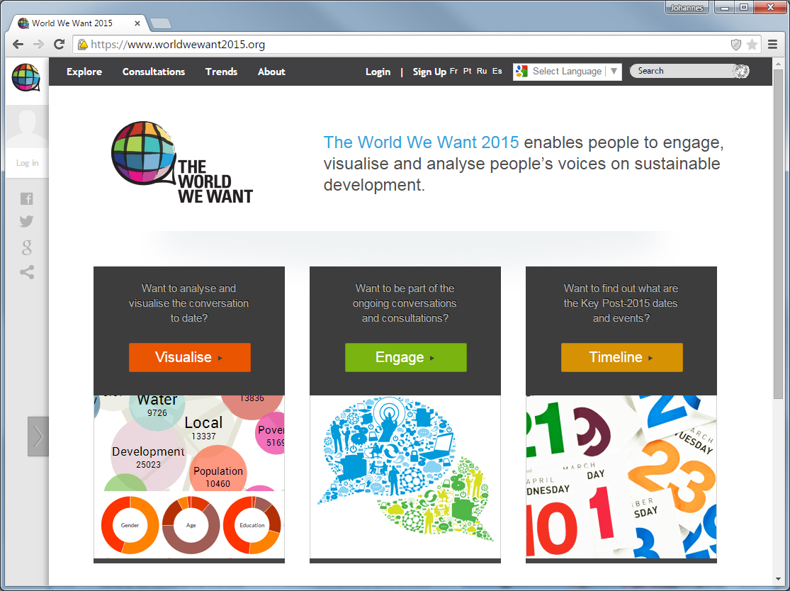
- The World We Want 2030 (in collaboration with UNDG agencies and civil society organisations)
The World We Want 2015 platform (renamed to World We Want 2030 after Sep 2015) has to date hosted online discussion spaces for 11 thematic consultations, over 30 of the 88 country consultations as well as many distinct consultations hosted by outside constituencies and partners. These consultations have brought in 34,000 new registered users and over 280,000 visitors generating over
3 million page views.
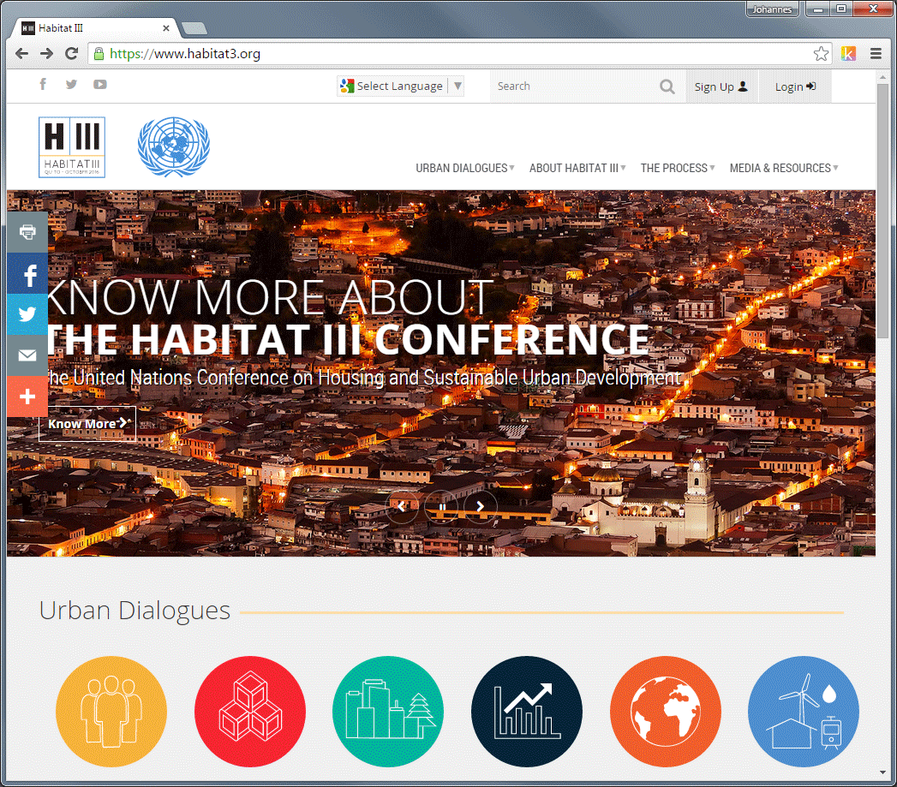
- The Urban Dialogues for Habitat III (in collaboration with UN HABITAT)
The online dialogue platform based on Teamworks has been launched in July 2015 to host public consultations in preparation to the Habitat III Conference in Quito in fall 2016. The cooperation between UN HABITAT and UNDP’s SD Cluster is supported by DIG’s KM team through platform and facilitation advisory services, on a cost recovery basis.

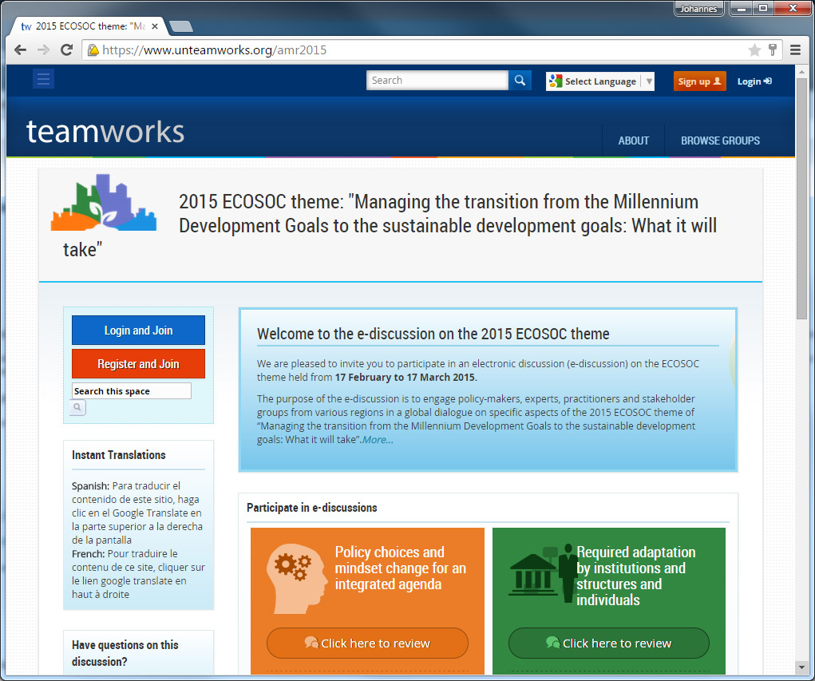
- ECOSOC’s 2015 Annual Ministerial Review Online Consultation (in collaboration with the UNDESA Office for ECOSOC Support and Coordination)
The public interface of Teamworks was used in the 2015 ECOSOC E-Discussion for the Annual Ministerial Review. Overall, the four thematic windows resulted in over 750 contributions from over 170 countries.
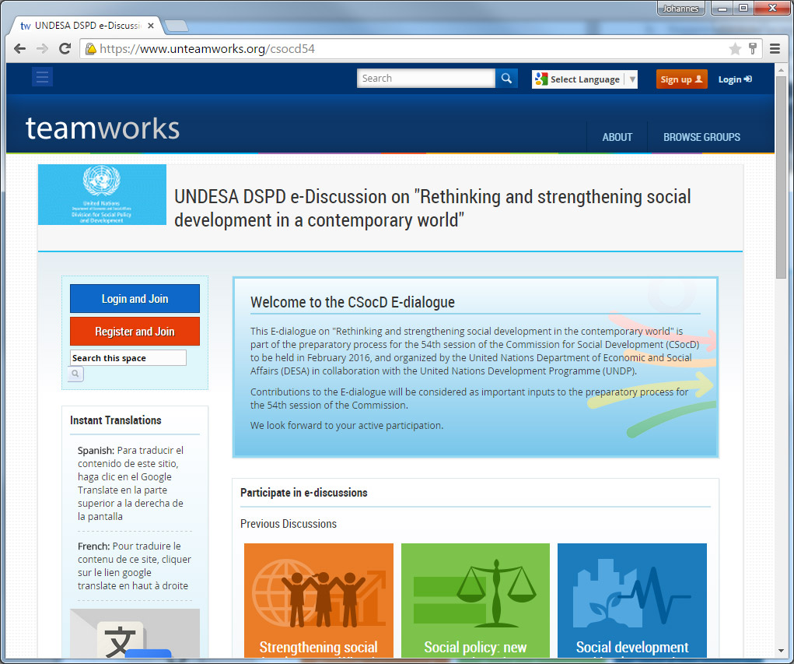
- UNDESA’s DSPD e-Discussion (in collaboration with the UNDESA Division for Social Policy and Development)
The E-dialogue of the preparatory process for the 54th session of the Commission for Social Development (CSocD) was hosted on the public interface of Teamworks. The online dialogue received over 320 contributions from 169 countries.
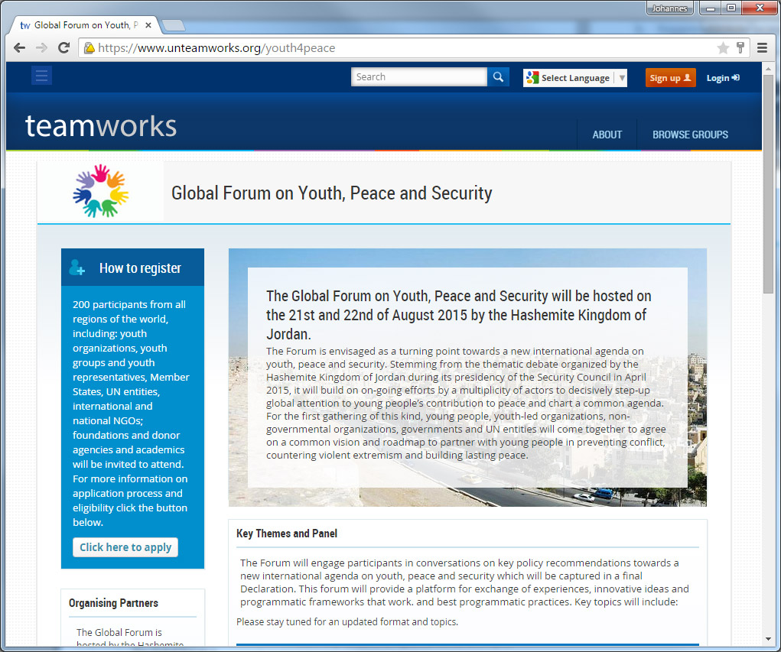
- Global Forum on Youth, Peace and Security (in collaboration with the Inter-Agency Network on Youth Development (IANYD), Office of the UN Secretary-General’s Envoy on Youth, Peacebuilding Support Office and UNFPA)
The public interface of the Teamworks platform was used in 2015 as an advocacy and community tool for the Global Forum on Youth, Peace and Security, hosting several online dialogues and events.

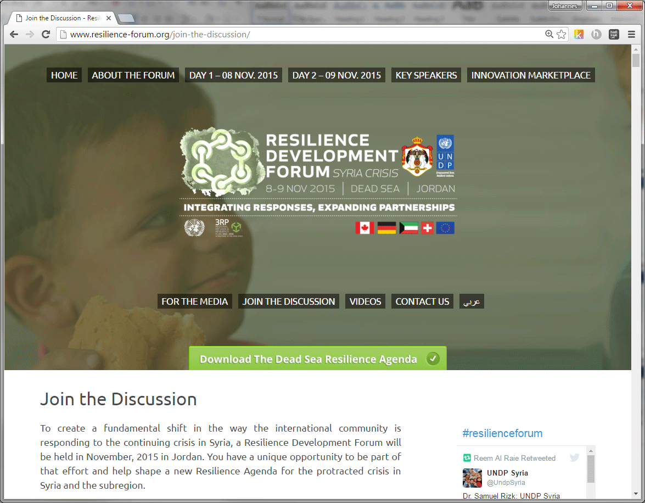
- Syria Resilience Development Forum (RDF)
The KM project supported the Resilience Development Forum event that was held in November 2015 in Jordan with an online global consultation to help shape a new Resilience Agenda for the crisis in Syria and the sub-region. The Consultation attracted over 3,200 visitors from 162 countries who posted nearly 100 comments in just over 2 weeks. The report on the RDF 2015 is being finalized and will be delivered by mid-2016.
Unlike all other KM activities within UNDP to date, the service offering of public consultations to external clients brings in revenue for UNDP in the form of cost recovery and service fees. In 2015, the DIG KM team collected cost-sharing revenues in the amount of $167,733 from partners to implement the above activities for them. The business model of knowledge management support to public consultations has enabled UNDP to become a trusted go-to knowledge broker among UN Agencies, governments, civil society organizations and the private sector. Initiatives such as World We Want are backed by the Secretary General's UN System Task Team to support UN system-wide preparations for the post-2015 UN development agenda.

For the implementation of consultation activities, the team spent $54,915.00 of XB funds within the KM project, and the remaining balance has been spent for maintenance costs under UNDP’s ICT Road Map, with some of it carried over to be spent in 2016 on IT management services to ensure promised functions and sustainability of the Public Dialogues service, and its ability to attract further cost-sharing contributions in the future.

Table 5: Project Budget – Activity 9
Activity | Approved Budget | Expenditure | Purpose
Public Online Dialogues and Consultations | $54,915.00 | $54,915.00 | - Consultancy to facilitate and manage World Humanitarian Summit Consultations  - Consultancy to plan, facilitate and manage Resilience Forum
Owner: Gayan Peiris

Next Steps (WHS): For 2016, the following consultations and dialogue support activities are in the pipeline:
- ECOSOC Discussion ‘Implementing the 2030 Agenda for Sustainable Development’
- Integrated DRR - CCA Mainstreaming Framework (Ongoing)
- World Humanitarian Summit (Ongoing – on cost recovery basis)
- Habitat III (Ongoing – on cost recovery basis)
- MyUNEA (Ongoing – on cost recovery basis)
- UNDP Cities Initiative – www.undp4urban.org (Will be released soon)
- World Water Forum – Government of Brazil (Agreement expected to be signed soon – on cost recovery basis)
- GPEDC Consultations (Website to launch in June)

Note on sustainability
While the development costs for new online consultation projects undertaken for external clients are always covered by cost-sharing contributions from these clients, to date the service has relied on the Teamworks platform being available. The UNDP ICT Roadmap has traditionally allocated funds to support its maintenance and the contracts with development teams. This made it possible to support successfully public consultation for both internal and external clients. With the switch from UNDP’s internal social networking infrastructure from Teamworks to Microsoft Office 365/Yammer, the KM team has received unequivocal indications that ICT Road Map funding for the public consultation platform’s maintenance will be available only through 2016, after which all support from corporate ICT budget will cease.

Once Teamworks is retired, however, public dialogues cannot be maintained in the same platform due to the complexity of the highly customized source code. Upgrading the code to a lightweight version would require a significant financial investment and funds to maintain the platform with a fully resourced development team.

The KM team is therefore preparing to retire the existing platform and re-package the public consultation offering in a way that would make it fully self-sustainable by Jan 2017, by charging external and internal clients the full amount that will incur for setting up each new consultation project, including website development, project management and facilitation services. By moving the technical infrastructure out of UNDP and outsourcing the technical development to a LTA vendor, the team will be able to bring down hosting and maintenance costs which will allow UNDP to stay competitive in the market for online consultation projects.

The downside going forward is that – due to the fact that platform maintenance is no longer subsidized by the ICT Road Map – internal UNDP clients cannot be served anymore free of charge as done in the past (e.g. Syria Resilience Development Forum) but will have to be charge based on actual costs incurred.

Output 4: KM measurement framework utilized to report on KM activities and performance

Activity: 11 - Monitoring and reporting on UNDP’s KM activities and progress

As per the global KM project, the KM team monitors and reports on progress and results of UNDP’s KM activities.

In 2015, the KM team as engaged the services of a Senior KM Expert on developing more detailed performance indicators for its own reporting on KM in UNDP which will give a more complete picture of KM performance in the organization than the few selected IRRF indicators would allow. The work of the consultant was completed in Dec 2015, which include:

- UNDP - KM Indicators Industry Research - FINAL 16 Dec 2015;
- UNDP - KM Measurement Framework - FINAL 25 Feb 2016; and
- UNDP - KM Measurement Framework - Standard Operating Procedures - FINAL 25 Mar 2016.

Owner: Johannes Schunter

Next Steps: The DIG KM team will start data collection in 2016 with a subset of indicators proposed by the framework.

Table 6: Project Budget – Activity 11
Activity | Approved Budget | Expenditure | Purpose
KM measurement framework | $21,000.00 | $21,000.00 | - Consultancy to develop KM measurement framework

Output 5: KM and learning mechanisms and principles integrated in consultants procurement and HR talent management processes

Activity 12 - Open UNDP-wide Expertise Roster

In 2015, the DIG KM team provided advisory support to RBAP which was in the process of developing a Talent Map for the Asia-Pacific Region within the UNDP intranet and Atlas, which – with the help of DIG’s Regional KM Team Leader in Addis – has since been taken up by other UNDP regions as well. By the end of 2015, the Regional KM Team Leader in Addis has taken over business ownership for the roll-out in the Africa from RBAP. This Talent Map will serve as a basis for expertise mapping in UNDP, and provides a path to institutionalize an expertise roster that can be tapped into for detail assignments and short-term projects by UNDP units globally. No funds have been used on this activity other than staff advisory time.

Owner: Marc LePage (Addis Regional Hub)

Next Steps: Explore ways to make expertise search part of the general intranet search, and facilitate triggers for capturing expertise profiles of staff.

Activity 14 – Knowledge Management Training

As part of general capacity building in KM, the DIG KM responded to a service request by the Human Rights Team in the BPPS/DG Cluster, to support a KM Needs Assessment for the Global Alliance of National Human Rights Institutions (GANHRI) based in Geneva. A KM Specialist from the KM team conducted the assessment over a period of 15 days, which included a 1-week mission to Geneva, and delivered a final report and presentation which was well received by the client. This engagement generated income for the KM Project in the amount of $12,750 for services provided by the KM team.
Owner: Johannes Schunter

Table 7: Project Budget – Activity 14
Activity | Approved Budget | Expenditure | Purpose
KM Training | $0 | -$12,750.00  (to be collected in 2016) | - Cost-recovery for services provided by staff to conduct KM Needs Assessment for GANHRI

Next Steps: Continue to provide training and advisory support on KM to business units throughout 2016.

Contact:

Johannes Schunter, Policy Specialist, Knowledge Services, BPPS/DIG
(johannes.schunter@undp.org)
Bernardo Cocco, Global Advisor, Knowledge and Innovation, BPPS/DIG
(bernardo.cocco@undp.org)

III. Annex

KM Project Activities (2014-2017)

- Knowledge capture and lessons learning
  - Activity 1: Lessons Learned Database
  - Activity 2: Lessons Learned Capture
  - Activity 3: Knowledge production and dissemination plans for Development Solution Teams
  - Activity 4: Revision of K-products development and dissemination
- Knowledge exchange and networking
  - Activity 5: Knowledge mobilization around Strategic Plan outcomes
  - Activity 6: Re-alignment of UNDP’s Knowledge Networks
  - Activity 7: Mutual Support Initiative (MSI)
- Openness and knowledge sharing
  - Activity 8: Public Blogging
  - Activity 9: Public Online Dialogues and Consultations
  - Activity 10: Regional South-South Knowledge Fairs
- Measurement and reporting
  - Activity 11: Monitoring and Reporting on UNDP’s KM activities and progress
- KM and learning in HR and procurement
  - Activity 12: Open UNDP-wide expertise roster of consultants
  - Activity 13: Embedding KM in HR processes
  - Activity 14: Knowledge Management Training

http://www.undp.org/knowledge
Please see Annex on page 16 for all activities in global KM project 2014-2017
In 2016 the OPG approved UNDP’s revised cost recovery policy for agency services. For the first time, the policy features a specific reference to the provision of knowledge management services by BPPS/KM team.

